Name : Khush Pithva 24BCE174
Subject : Data Structure (2CS501)
Practical no.: 9A
AIM :
Implement Binary search technique, which takes a list of unique values sorted in
descending order and a value to search for, and returns either the index of the value or
None, if the value isn’t in the list.
INPUT :
#include <bits/stdc++.h>
using namespace std;

int main() {
int n, x;
cin >> n;
int a[n];
for(int i = 0; i < n; i++)
cin >> a[i];
cin >> x;

int l = 0, r = n - 1;
bool found = false;

while(l <= r) {
int mid = (l + r) / 2;

if(a[mid] == x) {
cout << "Number Found at index: " << mid << endl;
found = true;
break;
}

if(a[mid] < x)
l = mid + 1;
else
r = mid - 1;
}

if(!found)
cout << "Not Found\n";

return 0;
}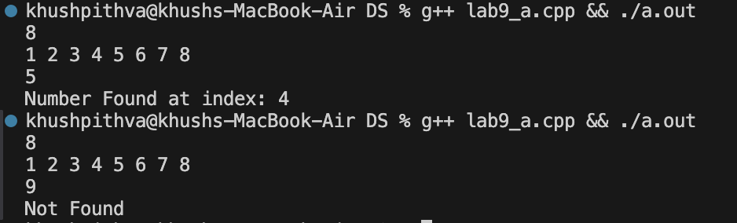
Practical No: 8(b)
Aim: Implement interpolation search algorithm to search an element from the array.
Input:
#include <iostream>
using namespace std;

int main() {
int n, x;
cout << "Enter number of elements: ";
cin >> n;

int a[n];
cout << "Enter elements (sorted): ";
for(int i = 0; i < n; i++)
cin >> a[i];

cout << "Enter value to search: ";
cin >> x;

int low = 0, high = n - 1;

while(low <= high && x >= a[low] && x <= a[high]) {

if(a[low] == a[high]) {
if(a[low] == x)
cout << "Number found at index: " << low << endl;
else
cout << "Not Found\n";
return 0;
}

int pos = low + ((x - a[low]) * (high - low)) / (a[high] - a[low]);

if(a[pos] == x) {
cout << "Number found at index: " << pos << endl;
return 0;
}

if(a[pos] < x)
low = pos + 1;
else
high = pos - 1;
}

cout << "Not Found\n";
return 0;
}
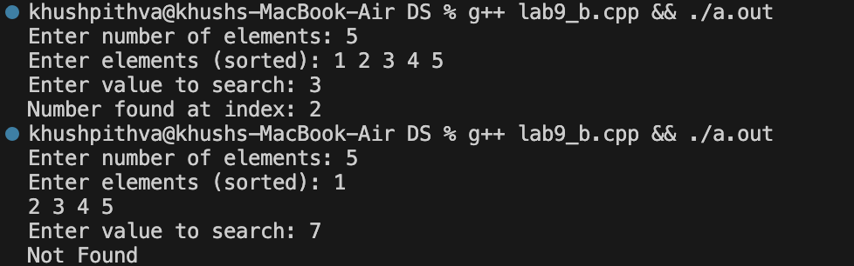

1.
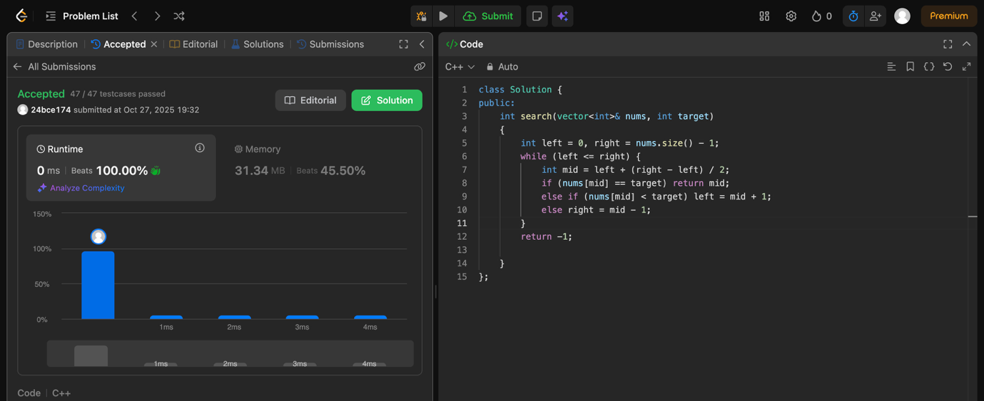

2.

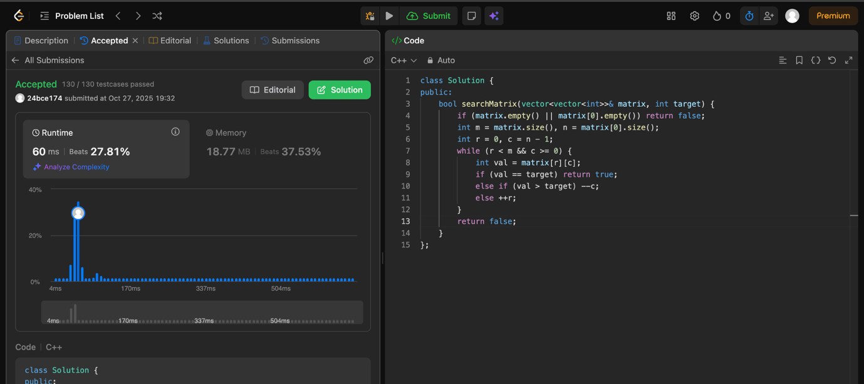

3.
